Optics02

***BCL-1050***

***Boat Scope***

**Optics & Night Vision evices-21**

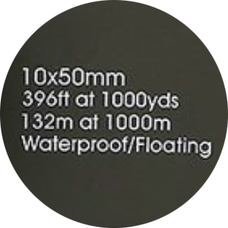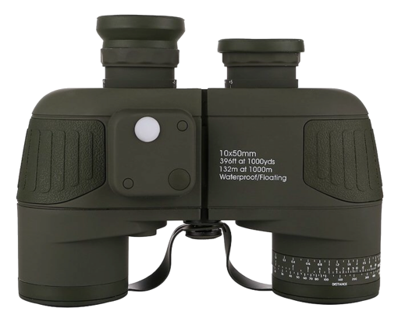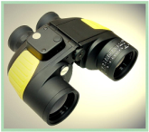

**Various colors available**

* Feature in high light transmittance and sharp image by utilizing high precision BAK4 lens.
* The high brightness is ideal for clear observation in night-time or low light condition.
* Automatic focus design.
* Meet IP67, with ability to immerse to water and float on the water.
* Allow to take the photograph by positioning mobile phone in front of the eyepiece with extra large caliber.
* Integrated range reticle & compass with illuminating function.
* Fitted with ranging scales to meet distance calculation purpose.

**Ranging scales for fast distance calculation**

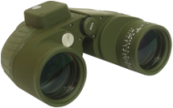

Calculation_BCL-750.png

**The Nitrogen is filled to prevent from a foggy lens**

**The large eyepiece can work with various camcorders**

**Reticle**

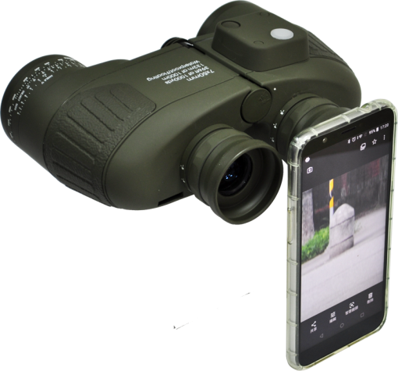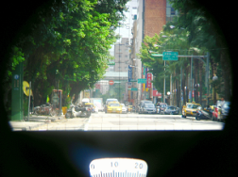

**No focus adjustment is needed. Allow to snapshot and record by mobile and camcorder.**

**Illuminated compass**

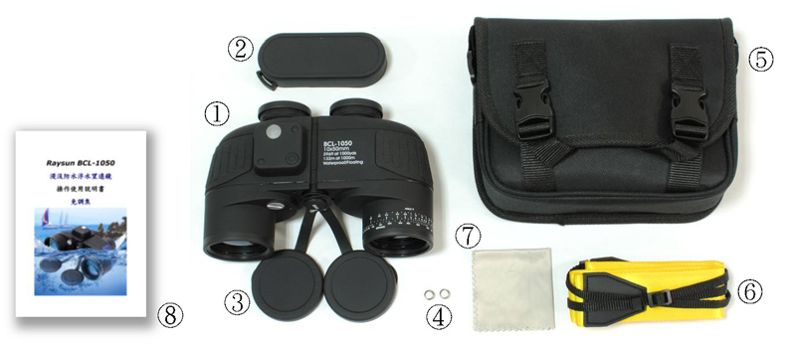

**🕮 Specifications:**

|  |  |
| --- | --- |
| **Objective Dia.** | 50mm |
| **Magnification** | 10× |
| **Field of View** | 7.5° |
| **Eye relief** | 22mm |
| **Inter-pupillary Distance** | 56-72mm |
| **Exit pupil diameter** | 7.1mm |
| **Resolution(Center)** | ≤5° |
| **Lens coating** | Multi-layer of coating |
| **Closest focusing range** | 5m |
| **Prism glass** | BAK-4 |
| **Sealed & filled with Nitrogen gas** | √ |
| **Built-in functions** | Reticle, compass  with illumination |
| **Diopter adjusting range** | -5 ~ +5 |
| **Size** | 187(L)x80(W)x145(H) mm+5mm |
| **Weight** | ≤900g |

**🕮 Standard package：**

|  |  |
| --- | --- |
| 1. Main unit | 5. Carry bag \*1 |
| 1. Eyepiece cap \*1 | 6. Floatable sling \*1 |
| 1. Objective lens cap \*2 | 7. Lens cleaning cloth \*1 |
| 1. Battery \*2 | 8. Manual \*1 |

The product color may vary from the catalog model, we will not notice in advance if the product accessories and specification is slightly modified.